

## Safe, Supported, and Ready to Learn

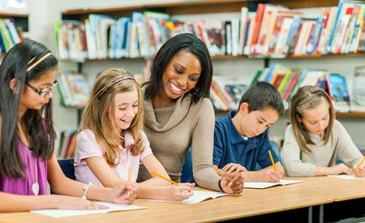

### A Unified Approach

Educators need the right preparation and tools to meet the very different needs of their students. To address the complexity of requirements for improving student behavior and outcomes while optimizing budgets and results, we offer a unified approach: the Second Step Suite.



### Build an Environment for Learning

By integrating our evidence-based Social-Emotional Learning (SEL) Program with our Bullying Prevention and Child Protection Units, we’ve formed a cohesive foundation for a safe and supportive learning environment. Together, these products can help you achieve real and lasting results.

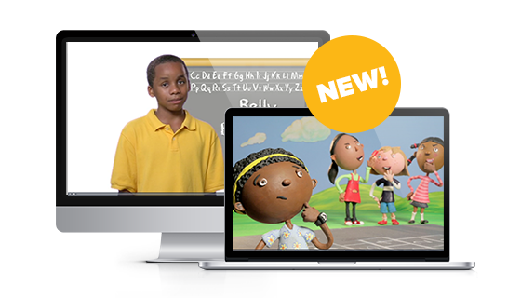

### Ditch the Discs!

Now you can stream lesson songs, photos, and videos right to the classroom. Streaming Lesson Media is included with our SEL program, Bullying Prevention Unit, and Child Protection Unit for Early Learning–Grade 5 (Spanish included through Grade 3).

## Why Choose the Second

## Step Suite?

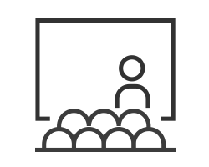

## Thriving Students

Students gain the skills they need to become caring, confident, and capable learners and problem-solvers.



## Supported Staff

Educators get the tools they need to create safe, respectful classrooms, so they spend less time managing behavior and more time teaching.

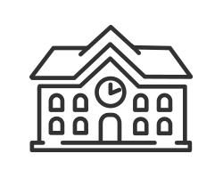

## Effective Schools

Our coordinated approach eliminates duplication of effort and improves outcomes, saving schools time and money.



## Sustained Success

Interactive staff training and ongoing support help ensure successful implementation and continuous improvement.

“Many of our students come to us without the social-emotional skills they need to become productive adults in a world that is increasingly becoming smaller and flatter. Since the skills can be taught, I feel it is imperative that we as educators do more to teach self-management, relationship building, cooperation, and conflict resolution.”

Meria Joel Carstarphen, EdD, Superintendent, Atlanta Public Schools

## Our Second Step Product Suite



##### Second Step SEL Program

Skills for Social and Academic Success

Early Learning–Grade 8

##### Bullying Prevention Unit

The Power to Create a Positive School Climate

Kindergarten–Grade 5

##### Child Protection Unit

Working Together to Keep Kids Safe from Abuse

Early Learning–Grade 5

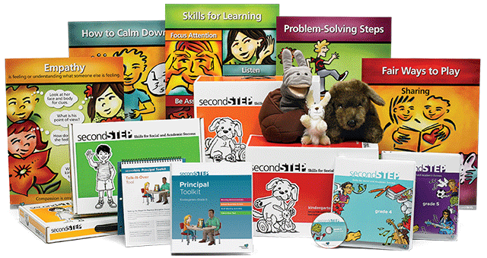

#### Second Step Social-Emotional Learning Program

Designed for Early Learning–Grade 8, the evidence-based Second Step SEL Program features tools, teaching aids, activity guides, and resources for classroom teachers to ensure successful social-emotional skills instruction. In addition to the classroom materials, we offer online resources to help plan lessons, train staff, and communicate with families

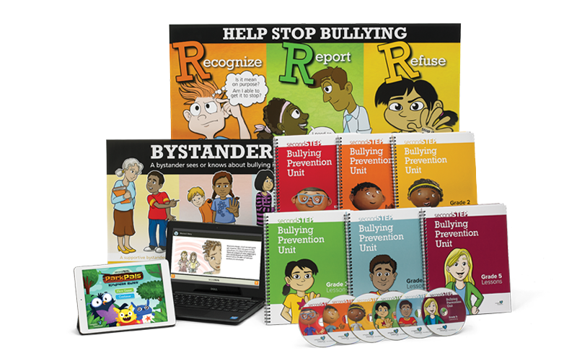

#### Bullying Prevention Unit

Created for Kindergarten–Grade 5, field-tested lessons make the best use of class time while videos, stories, and games model how to recognize, refuse, and report bullying. Training for school staff brings the program full circle by helping adults address bullying effectively.

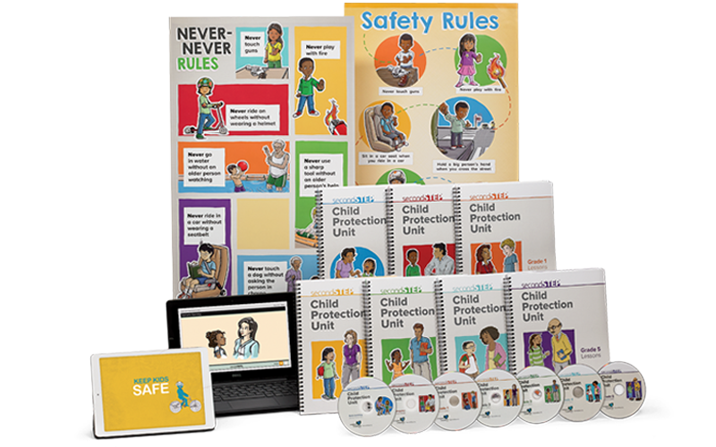

#### Child Protection Unit

Available for Early Learning–Grade 5, this unit has robust training that helps schools develop child protection policies and procedures and shows all staff how to recognize and respond to signs of abuse. Age-appropriate lessons teach students clear rules about touching safety. In addition, this unit also includes family materials that extend support to the home.

## Discover the Importance of SEL in the Classroom

By building skills in the classroom, we build skills for life.

#### Success Stories